**Add water sample (Bac-t)**

You will use the Samples folder – water – treated water kit

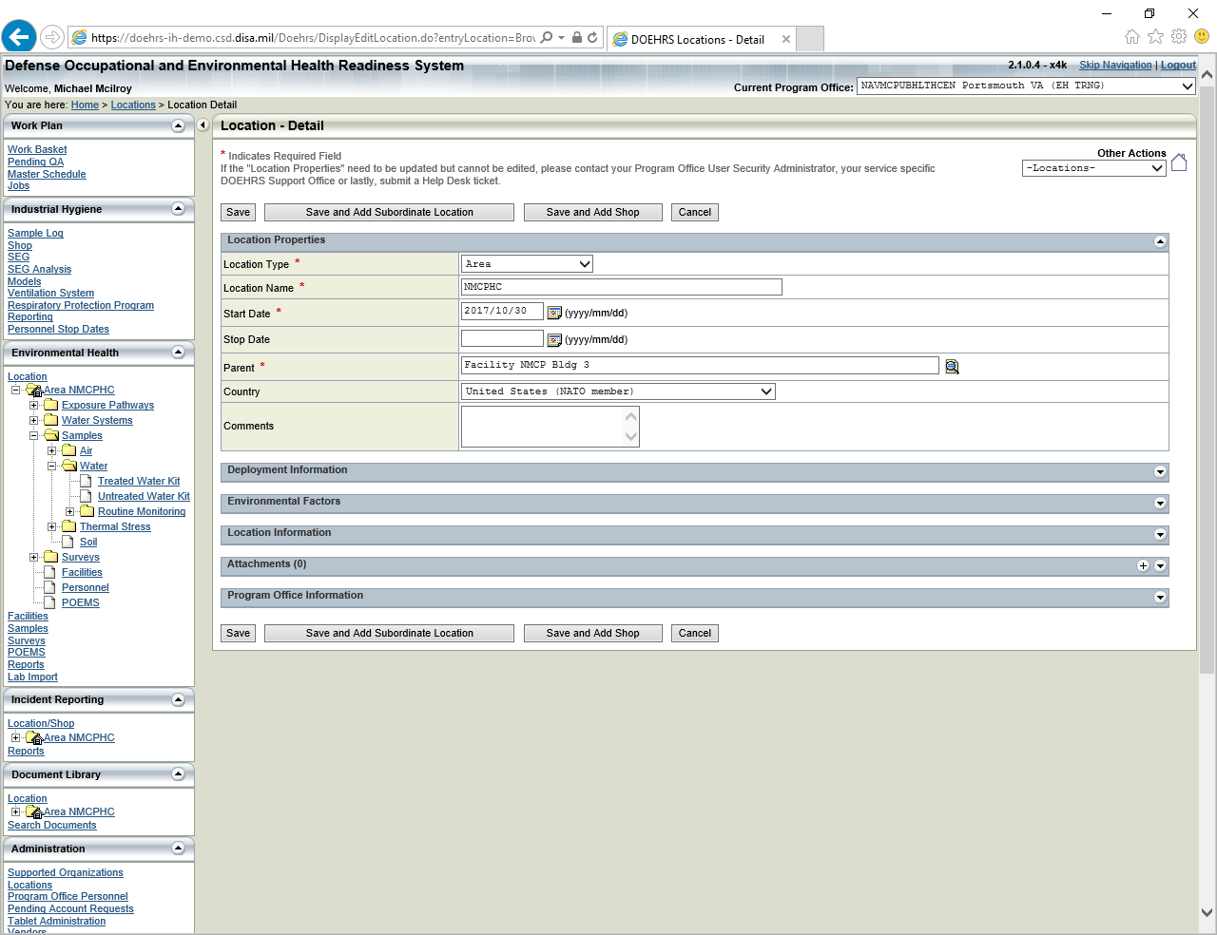

After you click on ‘treated water kit’ you will need to add a new sample by using the + icon on the upper right or via the other actions menu ‘add sample’

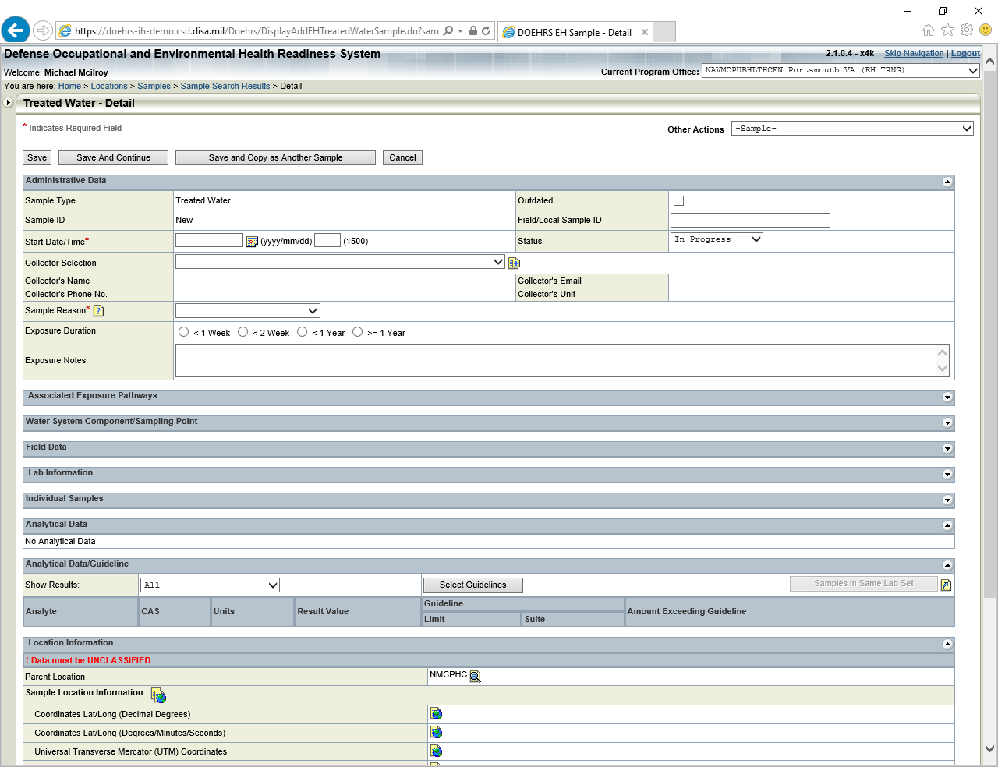

Ensure that the Administrative portion is completed. Sample reason is ‘other’. You will be required to put data in the exposure notes – add ‘Water Surveillance’. Click save and continue, then scroll down to the ‘Water System Sampling Point or Bottled Water’ area.

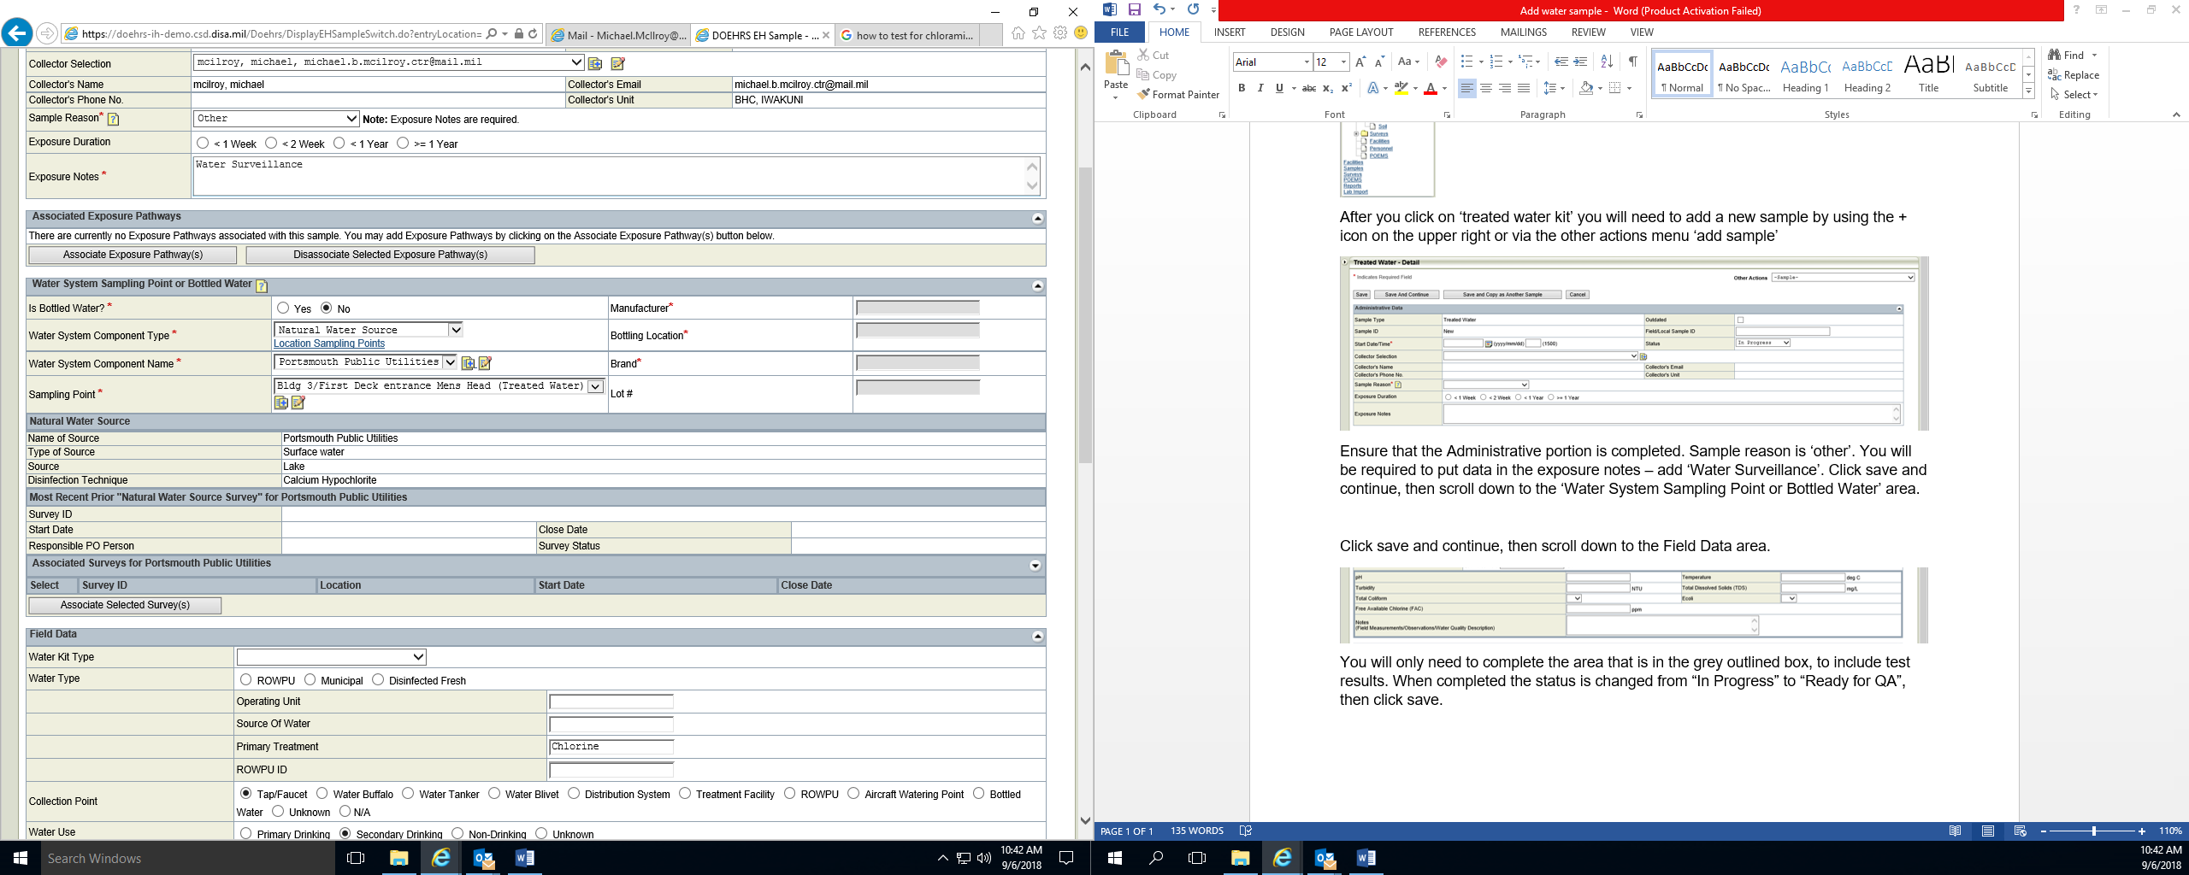

Here you will need to answer the required questions (Water System Component Type, Water System Component Name, Sampling Point) using the pick list. Click save and continue, then scroll down to the Field Data area.

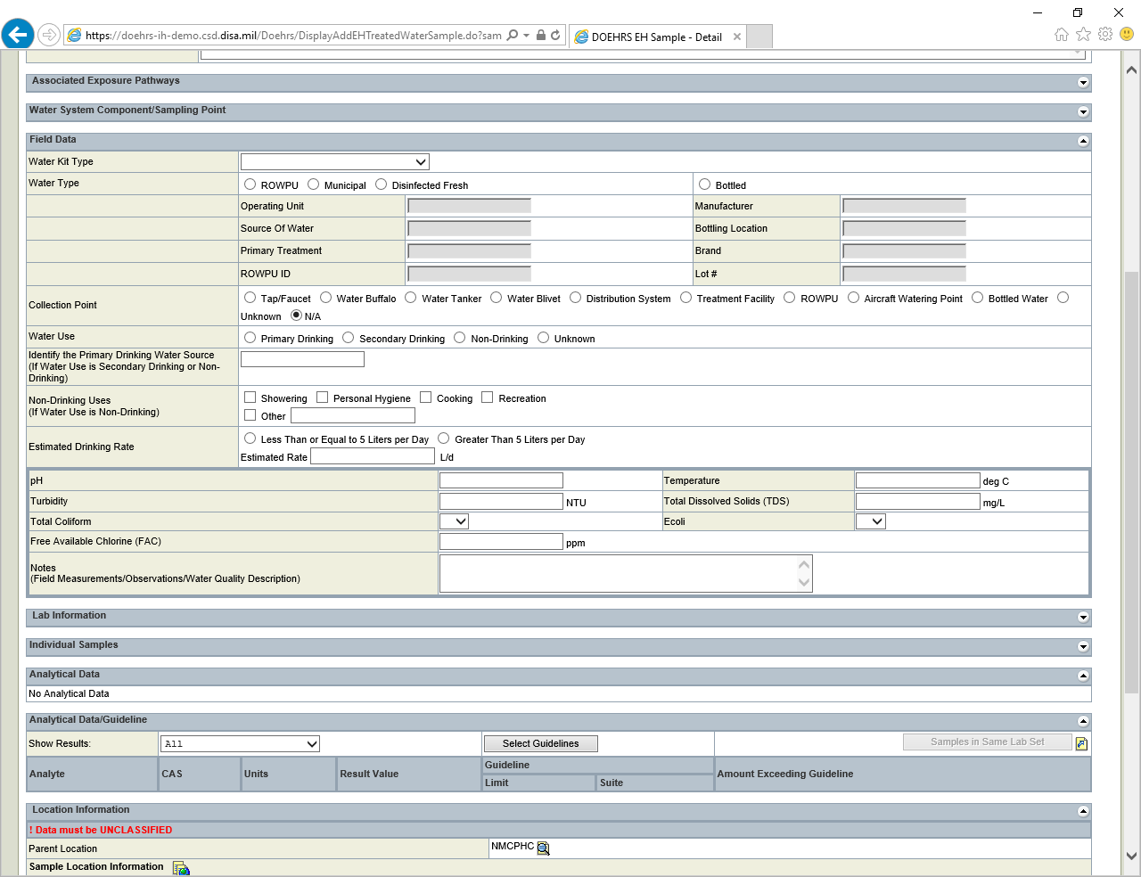

You will only need to complete the area that is in the grey outlined box, to include test results. When completed the status is changed from “In Progress” to “Ready for QA”, then click save.